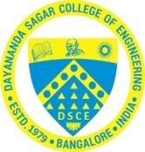

**DEPARTMENT OF ARTIFICIAL INTELLGENCE & MACHINE LEARNING**

**Alternate Assessment Tool & Quiz Report submitted for the subject**

***DESIGN & ANALYSIS OF ALGORITHM – 22AI43***

Submitted by

**Aditya B Rawanawar (1DS23AI005)**

**Bhoomika R Hegde (1DS23AI015) Manasa M (1DS23AI036)**

**Khushbu R Hajari (1DS23AI034)**

Under the Guidance of **Dr Reshma S** Associate Professor

Department of Artificial Intelligence & Machine Learning DSCE, Bengaluru

**VISVESVARAYA TECHNOLOGICAL UNIVERSITY JNANASANGAMA, BELAGAVI-590018, KARNATAKA, INDIA 2024-25**

**DEPARTMENT OF ARTIFICIAL INTELLGENCE & MACHINE LEARNING**

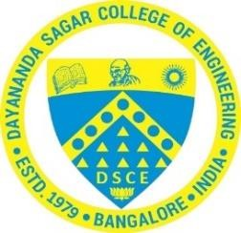

# CERTIFICATE

This is to certify that the Alternate Assessment Tool (AAT) entitled **“DEVELOPER CONCLAVE”** as part of **DESIGN ANALYSIS ALGORITHM – 22AI43**is a bonafide work carried out by Aditya B Rawanawar (1DS23AI005), Bhoomika R Hegde (1DS23AI015), Manasa M (1DS23AI036) , Khushbu R Hajari (1DS23AI034)as 20-mark component in partial fulfilment for the **4th semester** of Bachelor of Engineering in **Artificial Intelligence & Machine Learning** of the Visvesvaraya Technological University, Belagavi during the year 2024-25. The AAT & Quiz report has been approved as it satisfies the academic requirements prescribed for the Bachelor of Engineering degree.

**Signature of Faculty Signature of HOD**

**[Dr. Reshma S ] [Dr. Vindhya P Malagi]**

**DEPARTMENT OF ARTIFICIAL INTELLIGENCE & MACHINE LEARNING**

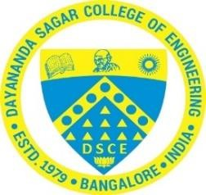

# DECLARATION

We declare that we abide by the ethical principles and commit to professional ethics and responsibilities and norms of the engineering practice. The work submitted in this report of **DESIGN ANALYSIS ALGORITHM- 22AI43**, IV Semester BE, AI&ML has been compiled by referring to the relevant online and offline resources to the best of our understanding and in partial fulfillment of the requirement for the award of the degree of Bachelor of Engineering in **Artificial Intelligence & Machine Learning**, at Dayananda Sagar College of Engineering, an autonomous institution affiliated to VTU, Belagavi during the academic year 2024-25.

We hereby declare that the same has not been submitted in part or full for other academic purposes.

Aditya B Rawanawar (1DS23AI005)

Bhoomika R Hegde (1DS23AI015)

Manasa M (1DS23AI036)

Khushbu R Hajari (1DS23AI034)

**Place: Date:**

# ACKNOWLEDGEMENT

It is a great pleasure for us to acknowledge the assistance and support of many individuals who have been responsible for the successful completion of this project.

We take this opportunity to express our sincere gratitude to Dayananda Sagar College of Engineering for giving us the opportunity to pursue our bachelor’s Degrees in this institution.

We would like to thank **Dr. B G Prasad**, Principal of Dayananda Sagar College of Engineering, for his constant encouragement and advice.

We would like to express my gratitude to **Dr. Vindhya P Malagi**, Professor and HOD, Department of Artificial Intelligence & Machine Learning, Dayananda Sagar College of Engineering, for her motivation and invaluable support throughout the completion of assignment.

Aditya B Rawanawar (1DS23AI005)

Bhoomika R Hegde (1DS23AI015)

Manasa M (1DS23AI036)

Khushbu R Hajari (1DS23AI034)

.

# ABSTRACT

The work presents a report on the study, development, and application of management principles and entrepreneurial strategies, emphasizing their impact on organizational growth and innovation. As part of the Alternate Assessment Tool (AAT) & Quiz for the subject **DESIGN ANALYSIS ALGORITHM – 22AI43**, a team of four students completed and submitted three assignments. These assignments covered the Developer conclave -where the leaders are born.

The team analyzed the working principles of **Rockwell Automations – Shridhar Hegde**. This interactive session with successful entrepreneurs offers invaluable lessons for aspiring business leaders. Sharing their triumphs and setbacks, entrepreneurs provide unique perspectives on innovation, resilience, and strategic decision-making. Through real-world examples and expert advice, participants gain actionable insights into launching and scaling ventures. Key takeaways include embracing calculated risk, fostering adaptability, and cultivating a growth mindset. By learning from developers experiences, future leaders can navigate challenges and propel their own entrepreneurial journeys.

**TABLE OF CONTENTS**

1. Assignment 1: Developer Conclave 1
2. Assignment 2: Developer 8
3. Assignment 3: Quiz 9
4. Learning Outcome from above Three assignments 10
5. **POSTER**

# ASSIGNMENT 1 ENTREPRENEUR CONCLAVE

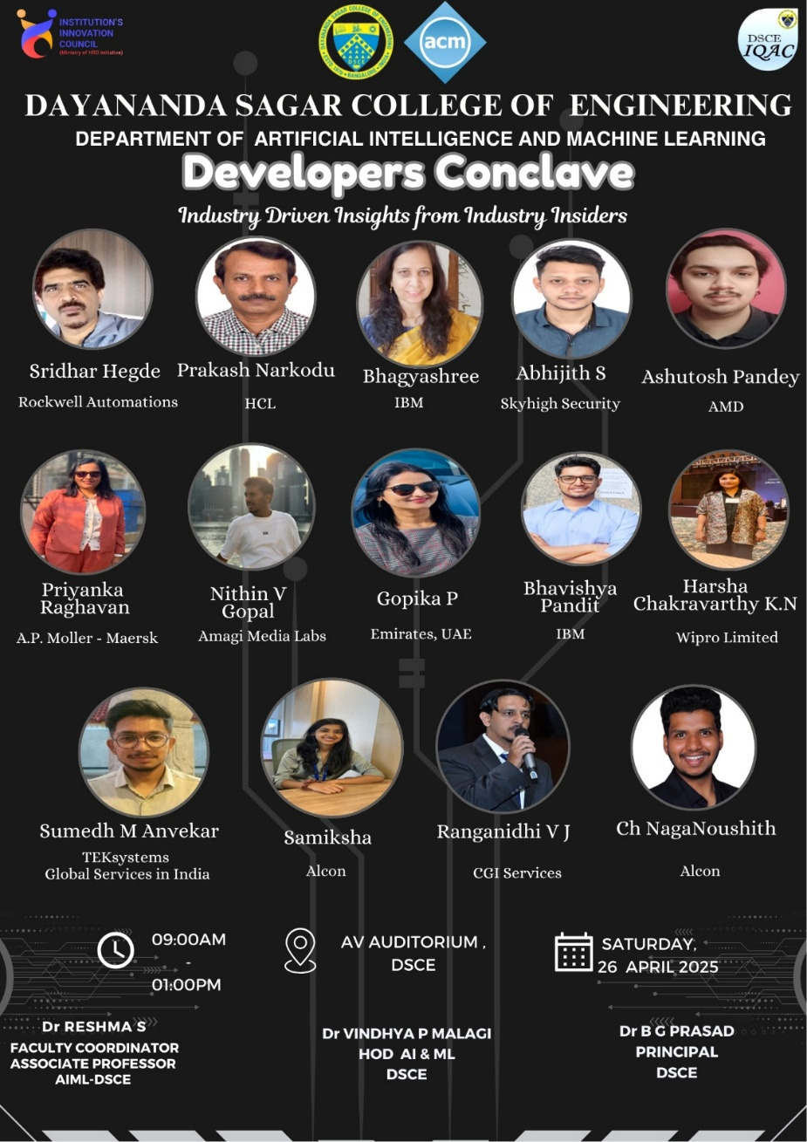

This poster showcases all the developers invited to the Developers Conclave along with their respective companies.

## SCHEDULE

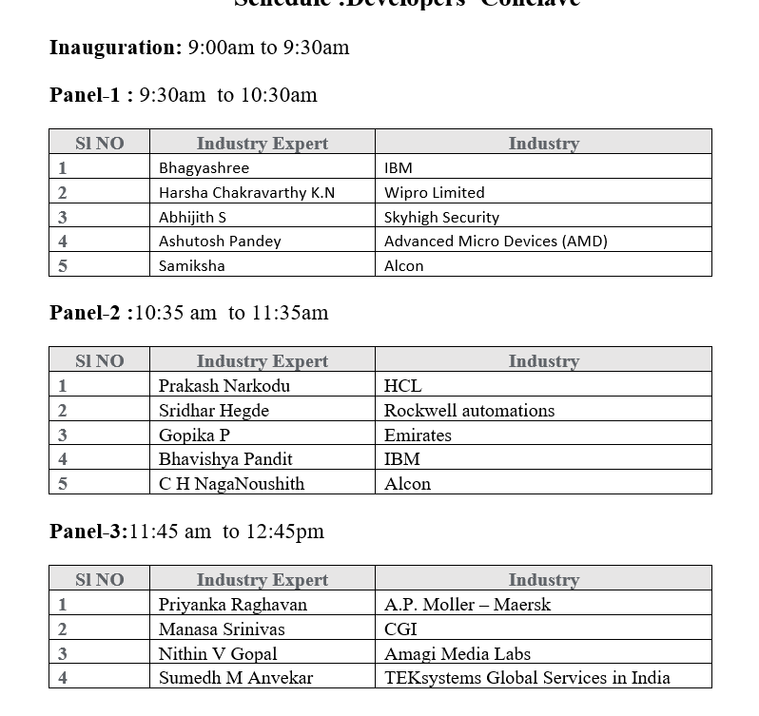

The Developer Conclave began with an inauguration session held from 9:00 AM to 9:30 AM. This was followed by three panel discussions featuring a diverse group of industry experts. Panel-1 took place from 9:30 AM to 10:30 AM and included speakers such as Bhagyashree from IBM, Harsha Chakravarthy K.N from Wipro Limited, Abhijith S from Skyhigh Security, Ashutosh Pandey from Advanced Micro Devices (AMD), and Samiksha from Alcon.

After a brief break, Panel-2 was conducted from 10:35 AM to 11:35 AM, with experts including Prakash Narkodu from HCL, Sridhar Hegde from Rockwell Automations, Gopika P from Emirates, Bhavishya Pandit from IBM, and C H NagaNoushith from Alcon.

The final session, Panel-3, was held from 11:45 AM to 12:45 PM and featured Priyanka Raghavan from A.P. Moller – Maersk, Manasa Srinivas from CGI, Nithin V Gopal from Amagi Media Labs, and Sumedh M Anvekar from TEKsystems Global Services in India. The event was well-structured and offered attendees valuable insights into current trends and innovations from seasoned professionals across various sectors in the tech industry.

## ABOUT THE COMPANY

Rockwell Automation is a globally recognized leader in industrial automation and digital transformation, with its headquarters in Milwaukee, Wisconsin. Established in 1903, the company has built a strong reputation for delivering advanced automation solutions that enhance manufacturing productivity and efficiency. It is best known for its Allen-Bradley range of automation hardware and the FactoryTalk suite of software products, both of which are widely used across industries such as automotive, pharmaceuticals, food and beverage, and energy.

With a presence in over 100 countries, Rockwell Automation helps businesses transition to smart manufacturing by integrating operational technology (OT) with information technology (IT). Its solutions support real-time data analytics, machine learning, and industrial IoT, enabling companies to make faster, smarter decisions. Rockwell is also committed to sustainability and innovation, continuously developing technologies that not only optimize operations but also promote safety and environmental responsibility in the manufacturing sector.

**Vision**

Rockwell Automation’s vision is to **bring the Connected Enterprise to life**, helping industrial companies achieve smarter, safer, and more sustainable operations.

**Mission**

Rockwell Automation’s mission is to make the world more productive and sustainable by providing innovative automation and digital solutions. The company aims to help businesses operate more efficiently, make smarter decisions, and achieve long-term success through advanced technologies and seamless integration of control and information.



## ABOUT THE DEVELOPER- MR. SHRIDHAR HEGDE

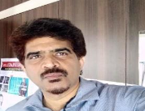Mr. Shridhar Hegde is a seasoned industrial leader with over 27 years of global experience in manufacturing, automation, and industrial engineering. As the Industrialization Manager at Rockwell Automation, he plays a key role in implementing advanced automation technologies and streamlining manufacturing processes to enhance efficiency and scalability. In addition to his corporate role, he is the founder of Adyadashu Engineering Solutions, where he brings his entrepreneurial vision to life by delivering tailored, sustainable engineering solutions. His deep operational expertise, combined with strategic leadership, allows him to drive impactful industrial innovations across diverse global markets.

## FEEDBACK AND SUGGESTION FROM DEVELOPER

The feedback from the developer emphasized the need for breakout sessions tailored to specific interests. These sessions would be highly beneficial for attendees by allowing them to delve deeper into their areas of interest and gain valuable knowledge related to their chosen fields.

## OUTCOME

The outcome of the developer talk focused on several key takeaways for aspiring developers:

* **Industry Exposure:** Students and attendees gained direct insights from experienced professionals across leading tech companies like IBM, Wipro, AMD, HCL, and more.
* **Career Guidance:** Panel discussions provided valuable advice on career paths, skill development, and industry expectations in the tech and automation sectors.
* **Networking Opportunities:** Participants had the chance to connect with industry experts, potentially opening doors for internships, mentorships, or future collaborations.
* **Awareness of Trends:** The sessions highlighted current trends in automation, digital transformation, cybersecurity, and smart manufacturing.
* **Inspiration and Motivation:** Real-life experiences and success stories shared by the speakers served to inspire students and young developers.

## PHOTOS

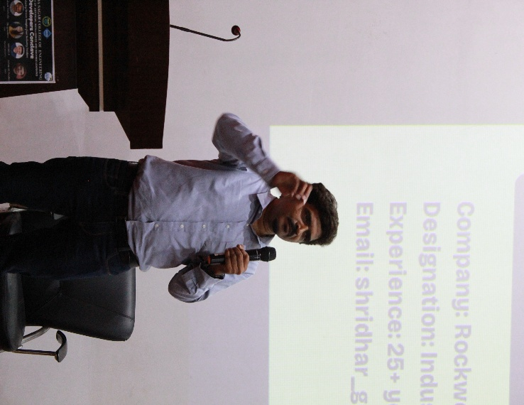

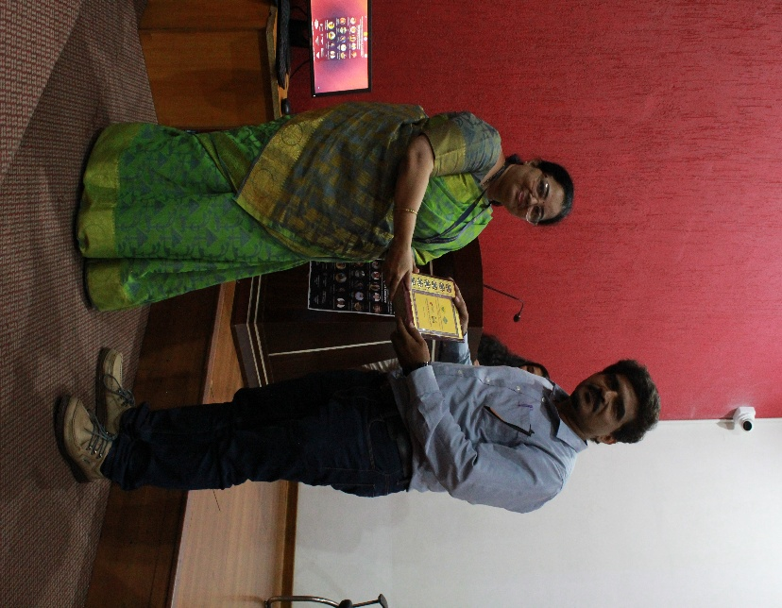

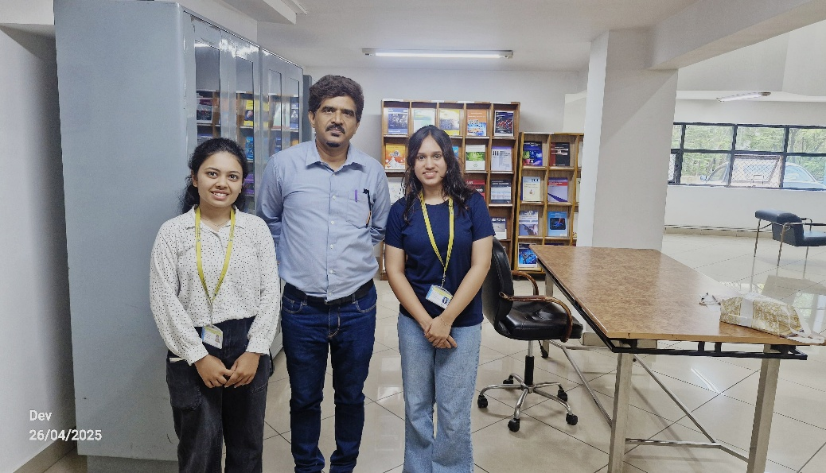

The above photos highlight key moments from the event, including the developer's talk, a group picture with the developer, and a photo of the memento presentation. These moments capture the essence of the interaction, the exchange of ideas, and the appreciation shown to the developer for their valuable contribution.

# ASSIGNMENT 2

|  |  |  |  |
| --- | --- | --- | --- |
| **Sl no** | **Student**  **Name** | **Developer**  **Name** | **Drive Link** |
| **1.** | **Aditya B Rawanawar** | **Shridhar Hegde** | https://drive.google.com/drive/folders/1UQwlZjn1RpmuL3QlxovbAHZbEk1bOKDn?usp=sharing |
| **2.** | **Bhoomika R Hegde** | **Shridhar Hegde** | https://drive.google.com/drive/folders/1UQwlZjn1RpmuL3QlxovbAHZbEk1bOKDn?usp=sharing |
| **3.** | **Manasa M** | **Shridhar Hegde** | https://drive.google.com/drive/folders/1UQwlZjn1RpmuL3QlxovbAHZbEk1bOKDn?usp=sharing |
| **4.** | **Khushbu R Hajari** | **Shridhar Hegde** | https://drive.google.com/drive/folders/1UQwlZjn1RpmuL3QlxovbAHZbEk1bOKDn?usp=sharing |

**ASIGNMENT 3**

## QUIZ LINK

<https://docs.google.com/forms/d/e/1FAIpQLSdfNV1JTuEiyNpncSFja3WUskWMJmuHpk9gSm3G-TdUg0wZvA/viewform?usp=header>

## MARK SHEET

1. **Aditya B Rawanawar -** [**https://docs.google.com/forms/d/e/1FAIpQLSfJVOiW14XVROMVUTA0gsU**](https://docs.google.com/forms/d/e/1FAIpQLSfJVOiW14XVROMVUTA0gsUSonqHNrPVDvEWrkFPZJsQMCMquw/viewscore?viewscore=AE0zAgB5flcDCRtZqmnHxpDxBD5A3RPdD3L176EfWV0K3vcPejoSGcr6T-TgxtL7jg)[**SonqHNrPVDvEWrkFPZJsQMCMquw/viewscore?viewscore=AE0zAgB5flc**](https://docs.google.com/forms/d/e/1FAIpQLSfJVOiW14XVROMVUTA0gsUSonqHNrPVDvEWrkFPZJsQMCMquw/viewscore?viewscore=AE0zAgB5flcDCRtZqmnHxpDxBD5A3RPdD3L176EfWV0K3vcPejoSGcr6T-TgxtL7jg)[**DCRtZqmnHxpDxBD5A3RPdD3L176EfWV0K3vcPejoSGcr6T-TgxtL7jg**](https://docs.google.com/forms/d/e/1FAIpQLSfJVOiW14XVROMVUTA0gsUSonqHNrPVDvEWrkFPZJsQMCMquw/viewscore?viewscore=AE0zAgB5flcDCRtZqmnHxpDxBD5A3RPdD3L176EfWV0K3vcPejoSGcr6T-TgxtL7jg)
2. **Bhoomika R Hegde –** [**https://docs.google.com/forms/d/e/1FAIpQLSfJVOiW14XVROMVUTA0gsU**](https://docs.google.com/forms/d/e/1FAIpQLSfJVOiW14XVROMVUTA0gsUSonqHNrPVDvEWrkFPZJsQMCMquw/viewscore?viewscore=AE0zAgCMXYgLl8WD0NJEwIobdHkPPFraTyfcelIZaK9dtoeq_UlPj3E7W6fj8PBLDA)[**SonqHNrPVDvEWrkFPZJsQMCMquw/viewscore?viewscore=AE0zAgCMX**](https://docs.google.com/forms/d/e/1FAIpQLSfJVOiW14XVROMVUTA0gsUSonqHNrPVDvEWrkFPZJsQMCMquw/viewscore?viewscore=AE0zAgCMXYgLl8WD0NJEwIobdHkPPFraTyfcelIZaK9dtoeq_UlPj3E7W6fj8PBLDA)[**YgLl8WD0NJEwIobdHkPPFraTyfcelIZaK9dtoeq_UlPj3E7W6fj8PBLDA**](https://docs.google.com/forms/d/e/1FAIpQLSfJVOiW14XVROMVUTA0gsUSonqHNrPVDvEWrkFPZJsQMCMquw/viewscore?viewscore=AE0zAgCMXYgLl8WD0NJEwIobdHkPPFraTyfcelIZaK9dtoeq_UlPj3E7W6fj8PBLDA)
3. **Manasa M-** [**https://docs.google.com/forms/d/e/1FAIpQLSfJVOiW14XVROMVUTA0gsU**](https://docs.google.com/forms/d/e/1FAIpQLSfJVOiW14XVROMVUTA0gsUSonqHNrPVDvEWrkFPZJsQMCMquw/viewscore?viewscore=AE0zAgByy2v0-uH5S973O5E_IP4bpgf-keWX9YNVeQmjpZ2a7SG49mWZ52V5u1Fgkg)[**SonqHNrPVDvEWrkFPZJsQMCMquw/viewscore?viewscore=AE0zAgByy2**](https://docs.google.com/forms/d/e/1FAIpQLSfJVOiW14XVROMVUTA0gsUSonqHNrPVDvEWrkFPZJsQMCMquw/viewscore?viewscore=AE0zAgByy2v0-uH5S973O5E_IP4bpgf-keWX9YNVeQmjpZ2a7SG49mWZ52V5u1Fgkg)[**v0-uH5S973O5E_IP4bpgf-keWX9YNVeQmjpZ2a7SG49mWZ52V5u1Fgkg**](https://docs.google.com/forms/d/e/1FAIpQLSfJVOiW14XVROMVUTA0gsUSonqHNrPVDvEWrkFPZJsQMCMquw/viewscore?viewscore=AE0zAgByy2v0-uH5S973O5E_IP4bpgf-keWX9YNVeQmjpZ2a7SG49mWZ52V5u1Fgkg)
4. **Khushbu R Hajari –** [**https://docs.google.com/forms/d/e/1FAIpQLSfJVOiW14XVROMVUTA0gsU**](https://docs.google.com/forms/d/e/1FAIpQLSfJVOiW14XVROMVUTA0gsUSonqHNrPVDvEWrkFPZJsQMCMquw/viewscore?viewscore=AE0zAgAqUIL27wYAJsnYp5HaW_-U_Reh4DgPr2jmyW4DzQiDrkzkWuRIfeaYWm5qxA)[**SonqHNrPVDvEWrkFPZJsQMCMquw/viewscore?viewscore=AE0zAgAqUI**](https://docs.google.com/forms/d/e/1FAIpQLSfJVOiW14XVROMVUTA0gsUSonqHNrPVDvEWrkFPZJsQMCMquw/viewscore?viewscore=AE0zAgAqUIL27wYAJsnYp5HaW_-U_Reh4DgPr2jmyW4DzQiDrkzkWuRIfeaYWm5qxA)[**L27wYAJsnYp5HaW_-**](https://docs.google.com/forms/d/e/1FAIpQLSfJVOiW14XVROMVUTA0gsUSonqHNrPVDvEWrkFPZJsQMCMquw/viewscore?viewscore=AE0zAgAqUIL27wYAJsnYp5HaW_-U_Reh4DgPr2jmyW4DzQiDrkzkWuRIfeaYWm5qxA)[**U_Reh4DgPr2jmyW4DzQiDrkzkWuRIfeaYWm5qxA**](https://docs.google.com/forms/d/e/1FAIpQLSfJVOiW14XVROMVUTA0gsUSonqHNrPVDvEWrkFPZJsQMCMquw/viewscore?viewscore=AE0zAgAqUIL27wYAJsnYp5HaW_-U_Reh4DgPr2jmyW4DzQiDrkzkWuRIfeaYWm5qxA)

**LEARNING OUTCOMES**

**ASSIGNMENT 1**

* Understand the phases of the Software Development Life Cycle (SDLC) and apply them in a structured manner for real-world application development.
* Identify and gather user requirements to develop functional and technical specifications for software solutions.
* Design and implement software applications using appropriate tools, programming languages, and frameworks.

**ASSIGNMENT 2**

* Work collaboratively in a team environment using Agile methodologies and tools like Git for version control.
* Develop problem-solving and debugging skills to resolve issues in code and optimize application performance.
* Perform software testing and validation to ensure functionality, reliability, and user satisfaction.

**ASSIGNMENT 3**

* Create and maintain clear documentation for code, system architecture, and user manuals.
* Integrate ethical considerations, data security, and legal compliance into the software development process.
* Evaluate application performance using metrics and tools; implement necessary enhancements